PROBLEM 3

equi = equipoints(3)

equi =

Columns 1 through 2

0 1.666666666666667e+00

Columns 3 through 4

3.333333333333333e+00 5.000000000000000e+00

rands = rand(1,1000) \* 5

max(arrayfun(@f3,rands) - LagrangeInterp(rands,equi,arrayfun(@f3,equi)))

ans =

4.665484950616623e-01

equi = equipoints(5)

equi =

0 1 2 3 4 5

max(arrayfun(@f3,rands) - LagrangeInterp(rands,equi,arrayfun(@f3,equi)))

ans =

1.795557877402223e-01

equi = equipoints(9)

equi =

Columns 1 through 2

0 5.555555555555556e-01

Columns 3 through 4

1.111111111111111e+00 1.666666666666667e+00

Columns 5 through 6

2.222222222222222e+00 2.777777777777778e+00

Columns 7 through 8

3.333333333333333e+00 3.888888888888889e+00

Columns 9 through 10

4.444444444444445e+00 5.000000000000000e+00

max(arrayfun(@f3,rands) - LagrangeInterp(rands,equi,arrayfun(@f3,equi)))

ans =

1.032175903176498e-01

equi = equipoints(17)

equi =

Columns 1 through 2

0 2.941176470588235e-01

Columns 3 through 4

5.882352941176471e-01 8.823529411764706e-01

Columns 5 through 6

1.176470588235294e+00 1.470588235294118e+00

Columns 7 through 8

1.764705882352941e+00 2.058823529411765e+00

Columns 9 through 10

2.352941176470588e+00 2.647058823529412e+00

Columns 11 through 12

2.941176470588235e+00 3.235294117647059e+00

Columns 13 through 14

3.529411764705882e+00 3.823529411764706e+00

Columns 15 through 16

4.117647058823529e+00 4.411764705882353e+00

Columns 17 through 18

4.705882352941177e+00 5.000000000000000e+00

max(arrayfun(@f3,rands) - LagrangeInterp(rands,equi,arrayfun(@f3,equi)))

ans =

1.078400318145850e-01

equi = equipoints(33)

equi =

Columns 1 through 2

0 1.515151515151515e-01

Columns 3 through 4

3.030303030303030e-01 4.545454545454546e-01

Columns 5 through 6

6.060606060606061e-01 7.575757575757576e-01

Columns 7 through 8

9.090909090909092e-01 1.060606060606061e+00

Columns 9 through 10

1.212121212121212e+00 1.363636363636364e+00

Columns 11 through 12

1.515151515151515e+00 1.666666666666667e+00

Columns 13 through 14

1.818181818181818e+00 1.969696969696970e+00

Columns 15 through 16

2.121212121212121e+00 2.272727272727273e+00

Columns 17 through 18

2.424242424242424e+00 2.575757575757576e+00

Columns 19 through 20

2.727272727272727e+00 2.878787878787879e+00

Columns 21 through 22

3.030303030303030e+00 3.181818181818182e+00

Columns 23 through 24

3.333333333333333e+00 3.484848484848485e+00

Columns 25 through 26

3.636363636363636e+00 3.787878787878788e+00

Columns 27 through 28

3.939393939393939e+00 4.090909090909091e+00

Columns 29 through 30

4.242424242424242e+00 4.393939393939394e+00

Columns 31 through 32

4.545454545454545e+00 4.696969696969697e+00

Columns 33 through 34

4.848484848484849e+00 5.000000000000000e+00

max(arrayfun(@f3,rands) - LagrangeInterp(rands,equi,arrayfun(@f3,equi)))

ans =

2.763192825670695e+00

equi = equipoints(3)

equi =

Columns 1 through 2

0 1.666666666666667e+00

Columns 3 through 4

3.333333333333333e+00 5.000000000000000e+00

x = linspace(0,5)

y = omega(equi)

y =

@(x)(prod(x-xvals))

y1 = arrayfun(y,x)

plot(x,y1)

equi = equipoints(5)

equi =

0 1 2 3 4 5

y = omega(equi)

y =

@(x)(prod(x-xvals))

y1 = arrayfun(y,x)

plot(x, y1)

equi = equipoints(9)

y = omega(equi)

y =

@(x)(prod(x-xvals))

y1 = arrayfun(y,x)

plot(x,y1)

equi = equipoints(17)

equi =

Columns 1 through 2

0 2.941176470588235e-01

Columns 3 through 4

5.882352941176471e-01 8.823529411764706e-01

Columns 5 through 6

1.176470588235294e+00 1.470588235294118e+00

Columns 7 through 8

1.764705882352941e+00 2.058823529411765e+00

Columns 9 through 10

2.352941176470588e+00 2.647058823529412e+00

Columns 11 through 12

2.941176470588235e+00 3.235294117647059e+00

Columns 13 through 14

3.529411764705882e+00 3.823529411764706e+00

Columns 15 through 16

4.117647058823529e+00 4.411764705882353e+00

Columns 17 through 18

4.705882352941177e+00 5.000000000000000e+00

y = omega(equi)

y =

@(x)(prod(x-xvals))

y1 = arrayfun(y,x)

plot(x,y1)

equi = equipoints(33)

equi =

Columns 1 through 2

0 1.515151515151515e-01

Columns 3 through 4

3.030303030303030e-01 4.545454545454546e-01

Columns 5 through 6

6.060606060606061e-01 7.575757575757576e-01

Columns 7 through 8

9.090909090909092e-01 1.060606060606061e+00

Columns 9 through 10

1.212121212121212e+00 1.363636363636364e+00

Columns 11 through 12

1.515151515151515e+00 1.666666666666667e+00

Columns 13 through 14

1.818181818181818e+00 1.969696969696970e+00

Columns 15 through 16

2.121212121212121e+00 2.272727272727273e+00

Columns 17 through 18

2.424242424242424e+00 2.575757575757576e+00

Columns 19 through 20

2.727272727272727e+00 2.878787878787879e+00

Columns 21 through 22

3.030303030303030e+00 3.181818181818182e+00

Columns 23 through 24

3.333333333333333e+00 3.484848484848485e+00

Columns 25 through 26

3.636363636363636e+00 3.787878787878788e+00

Columns 27 through 28

3.939393939393939e+00 4.090909090909091e+00

Columns 29 through 30

4.242424242424242e+00 4.393939393939394e+00

Columns 31 through 32

4.545454545454545e+00 4.696969696969697e+00

Columns 33 through 34

4.848484848484849e+00 5.000000000000000e+00

y = omega(equi)

y =

@(x)(prod(x-xvals))

y1 = arrayfun(y, x)

plot(x, y1)

cheb = chebyshev(3)

cheb =

Columns 1 through 2

4.809698831278217e+00 3.456708580912724e+00

Columns 3 through 4

1.543291419087276e+00 1.903011687217830e-01

rands = rand(1,1000) \* 5

max(arrayfun(@f3,rands) - LagrangeInterp(rands, cheb, arrayfun(@f3,cheb)))

ans =

3.799419424227836e-01

y = omega(cheb)

y =

@(x)(prod(x-xvals))

y1 = arrayfun(y,x)

cheb = chebyshev(3)

cheb =

Columns 1 through 2

4.809698831278217e+00 3.456708580912724e+00

Columns 3 through 4

1.543291419087276e+00 1.903011687217830e-01

x = linspace(0,5)

y = omega(cheb)

y =

@(x)(prod(x-xvals))

y1 = arrayfun(y,x)

plot(x, y1)

cheb = chebyshev(5)

cheb =

Columns 1 through 2

4.914814565722670e+00 4.267766952966369e+00

Columns 3 through 4

3.147047612756302e+00 1.852952387243698e+00

Columns 5 through 6

7.322330470336313e-01 8.518543427732972e-02

max(arrayfun(@f3,rands) - LagrangeInterp(rands, cheb, arrayfun(@f3,cheb)))

ans =

9.088703544725386e-02

y = omega(cheb)

y =

@(x)(prod(x-xvals))

y1 = arrayfun(y,x)

plot(x,y1)

cheb = chebyshev(9)

cheb =

Columns 1 through 2

4.969220851487845e+00 4.727516310470920e+00

Columns 3 through 4

4.267766952966369e+00 3.634976249348867e+00

Columns 5 through 6

2.891086162600577e+00 2.108913837399423e+00

Columns 7 through 8

1.365023750651133e+00 7.322330470336313e-01

Columns 9 through 10

2.724836895290803e-01 3.077914851215580e-02

max(arrayfun(@f3,rands) - LagrangeInterp(rands, cheb, arrayfun(@f3,cheb)))

ans =

4.646950663468297e-02

y = omega(cheb)

y =

@(x)(prod(x-xvals))

y1 = arrayfun(y,x)

plot(x,y1)

cheb = chebyshev(17)

cheb =

Columns 1 through 2

4.990486745229363e+00 4.914814565722670e+00

Columns 3 through 4

4.765769467591625e+00 4.547880110722479e+00

Columns 5 through 6

4.267766952966369e+00 3.933941090877616e+00

Columns 7 through 8

3.556545654351749e+00 3.147047612756302e+00

Columns 9 through 10

2.717889356869145e+00 2.282110643130855e+00

Columns 11 through 12

1.852952387243698e+00 1.443454345648252e+00

Columns 13 through 14

1.066058909122385e+00 7.322330470336313e-01

Columns 15 through 16

4.521198892775202e-01 2.342305324083753e-01

Columns 17 through 18

8.518543427732927e-02 9.513254770636248e-03

max(arrayfun(@f3,rands) - LagrangeInterp(rands, cheb, arrayfun(@f3,cheb)))

ans =

9.217953520368027e-03

y = omega(cheb)

y =

@(x)(prod(x-xvals))

y1 = arrayfun(y,x)

plot(x,y1)

cheb = chebyshev(33)

cheb =

Columns 1 through 2

4.997332437005931e+00 4.976026077188013e+00

Columns 3 through 4

4.933595135901732e+00 4.870401618977414e+00

Columns 5 through 6

4.786984671220052e+00 4.684055976615924e+00

Columns 7 through 8

4.562493686495756e+00 4.423334927457198e+00

Columns 9 through 10

4.267766952966369e+00 4.097117014129903e+00

Columns 11 through 12

3.912841036056480e+00 3.716511196417141e+00

Columns 13 through 14

3.509802512179737e+00 3.294478548954754e+00

Columns 15 through 16

3.072376374875335e+00 2.845390887379706e+00

Columns 17 through 18

2.615458646614349e+00 2.384541353385651e+00

Columns 19 through 20

2.154609112620295e+00 1.927623625124665e+00

Columns 21 through 22

1.705521451045247e+00 1.490197487820263e+00

Columns 23 through 24

1.283488803582860e+00 1.087158963943520e+00

Columns 25 through 26

9.028829858700973e-01 7.322330470336313e-01

Columns 27 through 28

5.766650725428026e-01 4.375063135042438e-01

Columns 29 through 30

3.159440233840765e-01 2.130153287799477e-01

Columns 31 through 32

1.295983810225856e-01 6.640486409826796e-02

Columns 33 through 34

2.397392281198751e-02 2.667562994068895e-03

max(arrayfun(@f3,rands) - LagrangeInterp(rands, cheb, arrayfun(@f3,cheb)))

ans =

1.852616161056586e-04

y = omega(cheb)

y =

@(x)(prod(x-xvals))

y1 = arrayfun(y,x)

plot(x,y1)

PROBLEM 3

EQUIDISTANT POINTS

N=3

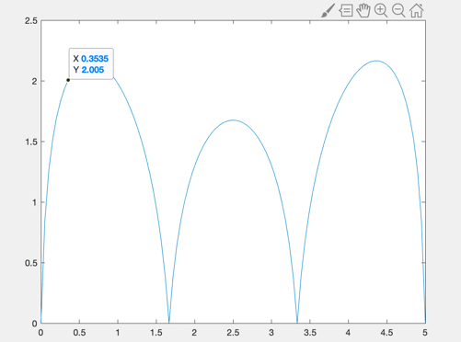

N=5

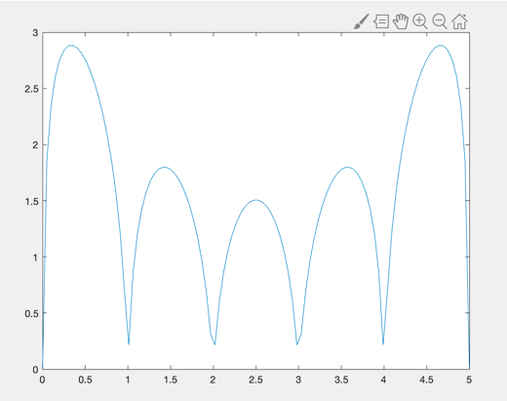

N=9

N=17

N=33

CHEBYSHEV POINTS

N=3



N=5



N=9

N=17

N=33

